David Mead

**Optimization 1:**

**Valid-Moves Heuristic on Next Variable (and Randomly Choosing the Value)**

The problem I wanted to solve was determining the row that I should put the next queen in. I figured that I could do this by ranking the row based on the number of moves that were available in that row. I thought that if I chose the row with the most number of legal slots for queens, I would cancel out less options and leave a more flexible board to work with for the next moves, and thus have to backtrack less.

For all charts, Bx is the number of boards/states processed for algorithm x, and Tx is the runtime.

|  |  |  |  |  |
| --- | --- | --- | --- | --- |
| n | Ba | Ta | Bb | Tb |
| 10 | 102 | 0.003 | 54 | 0.001 |
| 11 | 52 | 0.002 | 191 | 0.006 |
| 12 | 261 | 0.009 | 172 | 0.007 |
| 13 | 111 | 0.005 | 20 | 0.001 |
| 14 | 1899 | 0.08 | 366 | 0.018 |
| 15 | 1359 | 0.059 | 27 | 0.002 |
| 16 | 10052 | 0.533 | 66 | 0.004 |
| 17 | 5374 | 0.315 | 210 | 0.012 |
| 18 | 41299 | 2.523 | 396 | 0.028 |
| 19 | 2545 | 0.169 | 732 | 0.05 |
| 20 | 199635 | 14.407 | 915 | 0.067 |

Before I spent too much time doing this however, I tried a few ways to order the variables. I first compared going from row 0 to n vs. n to 0, and unsurprisingly got equal results in time and boards visited. I then tried sorting based on distance from the middle (abs((size/2)-row)) and got the about the same results. This makes sense because if you decide the next row to change systematically without taking in to account the location of the queens, you will be guaranteed to have to back track many times, as there is no way to “get lucky” or make an informed decision.

a: basic original csp

b: var and val determined randomly

I then tried determining it randomly, and as you would expect, I got some runtimes that were very fast, and a few that were pretty long. I sorted the value assigning process randomly as well, and it improved the efficiently of the code far more significantly than I had imagined it would. This is not only because I could ‘get lucky’ but also because it gives all board positions an equal chance. Say for example in order to be solved, there MUST be a queen in position (n, n). For the non-random code to put a queen there, it would take ages, because it would try every possibility before it to get there. With the random assignment, however, there is a probability of about 1/(n2) that the next move will put a queen there.

b: var and val determined randomly

c: valid-moves heuristic on var

|  |  |  |  |  |
| --- | --- | --- | --- | --- |
| n | Bb | Tb | Bc | Tc |
| 10 | 132 | 0.004 | 12 | 0.002 |
| 15 | 230 | 0.011 | 18 | 0.006 |
| 20 | 142 | 0.013 | 70 | 0.043 |
| 25 | 4172 | 0.556 | 25 | 0.036 |
| 30 | 1869 | 0.328 | 30 | 0.067 |
| 35 | 13800 | 3.585 | 109 | 0.222 |
| 40 | 977 | 0.238 | 66 | 0.271 |
| 45 | 4766 | 1.487 | 68 | 0.366 |
| 50 | 3221 | 1.144 | 164 | 0.743 |

After enough of that, I started making a real heuristic. In order to sort them, I counted the number of valid moves (cols that the queens can be in without being attacked or attacking others) in each row. This was done just by looping through each col of each row and determining if moving there would cause any problems. I kept the random sorting on the value determining function. I was a bit worried that all the extra time it would take me to calculate the valid moves would negate the time saved by not having to visited as many boards and backtrack as much, but that was not the case. When I first implemented the heuristic, I found that it drastically increased the time and the number of boards I had to visited. I then tried sorting in reverse order, so that the rows with the least number of available moves are assigned values first, and this dropped the number of boards to visited and the runtime significantly.

This improvement makes sense because at each move we are assigning values to variables that only have one or two valid variables, so we are less likely to assign it an incorrect value that we will have to change later. If we think of this like the color problem we did in class, prioritizing the variables based on how many variables are allowed in them would be like starting by assigning random colors to all the boxes that don’t touch each other first, and then having to go in and fill the ones in between and inevitably reassign the original boxes to different colors. This would be a terrible way to solve it. Alternatively, if you sort based on the most constricted boxes, you could be almost certain that the color you chose would be correct, and there would thus be a very limited chance that you would ever have to go back and change it.

**Optimization 2:**

**Hill Climbing**

|  |  |  |  |  |
| --- | --- | --- | --- | --- |
| n | Bc | Tc | Bd | Td |
| 10 | 12 | 0.002 | 16 | 0.001 |
| 15 | 18 | 0.006 | 1608 | 0.288 |
| 20 | 70 | 0.043 | 138 | 0.041 |
| 25 | 25 | 0.036 | 181 | 0.099 |
| 30 | 30 | 0.067 | 532 | 0.363 |
| 35 | 109 | 0.222 | 520 | 0.355 |
| 40 | 66 | 0.271 | 468 | 0.450 |
| 45 | 68 | 0.366 | 863 | 0.916 |
| 50 | 164 | 0.743 | 447 | 0.667 |
| 55 | 83 | 0.743 | 420 | 0.938 |
| 60 | 134 | 1.251 | 894 | 2.005 |
| 65 | 65 | 1.241 | 457 | 0.936 |
| 70 | 193 | 2.367 | 465 | 1.220 |

Next, I tried sorting the values based on how many other spaces they would make illegal, but this didn’t help much, presumably because the time it took to make the heuristic calculation outweighed the time it took to just make a random move and backtrack occasionally, especially when I had my other heuristic already on the variables cutting down the number of possible values down significantly. I also made my code more efficient, but because this didn’t change the number of boards I checked, my runtimes dropped only slightly. I decided to try “hill climbing”, which involved starting at a random board state and shifting the already places queens around until a valid solution was found. I imagined that this would sort faster because not only would there be a chance that we start close to a valid board state, but we could also make each of our moves more informed, because there is more data (already places queens) to work with.

c: backtracking with heuristic on var

d: basic hill climber

I started with a randomly generated state, and then until the number of conflicts was 0, I would pick a random row and assign it to the column in that row that caused the least collisions. If the new state had less collisions than the old, state, I would set the old state to the new state, and it would recur. Otherwise, I kept with the old state.

This only worked when the randomly generated state function was lucky enough to guess a valid state. Crap. I decided to try tracking everything, the number of visited states, the number of conflicts, the current state, etc, and found that because determining the next variable was too rigid of a formula, it would return the same value for the same variable over and over again, even if there were other values with an equal number of conflicts.

To combat this, I added a random decimal to the end of each conflict count so that the same value wasn’t chose over and over again. This helped, but my code would then get stuck on the part where I checked if the new state was better than the old state, because when the number of conflicts was the same, it would be determined solely by the randomly generated number, so I ditched that if statement.

This worked very well, and it makes a lot of sense. Rather than having to fill up a board with limited information (not all the queens on the board) and backtrack whenever it got stuck, with hill-climbing, the program has way more data to make decisions with, and it has to back track less. In fact, I was able to implement a solution that never explicitly backtracked, it just kept moving forward and would correct itself when needed (climb_3). There was also the chance that the random state method would spit out a board that was only a few moves away from a solution, which made solving it very fast.

|  |  |  |  |  |
| --- | --- | --- | --- | --- |
| n | Bd | Td | Be | Te |
| 10 | 16 | 0.001 | 83 | 0.010 |
| 15 | 1608 | 0.288 | 187 | 0.049 |
| 20 | 138 | 0.041 | 25 | 0.013 |
| 25 | 181 | 0.099 | 63 | 0.044 |
| 30 | 532 | 0.363 | 126 | 0.123 |
| 35 | 520 | 0.355 | 60 | 0.072 |
| 40 | 468 | 0.450 | 60 | 0.092 |
| 45 | 863 | 0.916 | 55 | 0.109 |
| 50 | 447 | 0.667 | 53 | 1.303 |
| 55 | 420 | 0.938 | 113 | 0.468 |
| 60 | 894 | 2.005 | 88 | 0.354 |
| 65 | 457 | 0.936 | 66 | 0.297 |
| 70 | 465 | 1.220 | 98 | 0.419 |
| 75 | 1497 | 4.609 | 72 | 0.355 |
| 80 | 2239 | 6.860 | 59 | 0.332 |
| 85 | 1006 | 4.039 | 180 | 1.079 |
| 90 | 1953 | 9.529 | 179 | 1.115 |
| 95 | 1650 | 7.985 | 168 | 1.229 |

**Optimization 3:**

d: basic hill climber

e: h-c with valid-moves heuristic on var

**Variable Heuristic on Hill Climber, Start State**

After getting a working hill-climber method, I tried to find ways to determine the randomized values (the initial state and the next row to change) in a better way. I first tried using the next row determiner from my first improvement in this hill climber methods. This was pretty simple to implement, and it worked nicely, because the concept of “which variable do I change next” is the same whether it’s in backtracking or hill-climbing.

|  |  |  |  |
| --- | --- | --- | --- |
| n | Bf | Tf | n % 6 |
| 84 | 2 | 0.01471 | 0 |
| 85 | 0 | 0.00587 | 1 |
| 86 | 2 | 0.01585 | 2 |
| 87 | 79 | 0.56174 | 3 |
| 88 | 111 | 0.71715 | 4 |
| 89 | 0 | 0.00307 | 5 |
| 90 | 2 | 0.01558 | 0 |
| 91 | 0 | 0.00353 | 1 |
| 92 | 22 | 0.18803 | 2 |
| 93 | 182 | 1.36733 | 3 |
| 94 | 83 | 0.61882 | 4 |
| 95 | 0 | 0.00506 | 5 |

I’m not sure if this next part counts as a csp, but I tried experimenting with the start states to cut down on the number of boards it had to visit. I initially tried starting with the basic pattern that we would get in apcs, where you put queens in this pattern: because I figured that was a solid guess for most boards because the only way collisions could occur is along the diagonals. When I ran this however, I saw a very interesting pattern in the boards visited/runtimes. When n%6 was 1 or 3, the pattern would be a solution to the board, when n%6 was 0 or 2, the pattern would be pretty close, but not an exact solution, and when n%6 was 3 or 4, it was a long shot (there were about n/3 collisions to start). I printed out (on paper) the board sizes for each of the different n%6 options (0 to 5) when I got home and tried to figure out why this pattern occurs. Basically, if there are queens in opposite corners, (n%6 == 0, 2, 4) there must only be at least one collision (those two queens). For 0 and 2, that's the only collision, so it’s quick to solve. For 4 (and 3) all the inner queens collide across diagonals, and because about 2/3rds of the queens are “inner queens” three are n/3 collisions. Finally, for 1 and 5, nothing lines up to collide, so it’s already solved. I tried developing a different pattern (flipped and rotated) for when n%6 == 4, and got those runtimes equal to when n%6 == 1 or 3.

x · · · · · · ·

· · x · · · · ·

· · · · x · · ·

· · · · · · x ·

· x · · · · · ·

· · · x · · · ·

· · · · · x · ·

· · · · · · · x

f: pattern on starting board

I then forgot about the whole “making the code better thing” and spent a few hours adding a feature that graphs the boards visited and runtimes for increasing sizes as they come in. Run live_graph() to see it if you have matplotlib already installed. Right now, I have it set to run my fastest hill climber from size 10 to 100, but you can play around to see my various algorithms working. Unfortunately, I haven’t added a way to race them against each other yet.

After remembering that I still had code to optimize, I consulted the almighty Google to see if there was a pattern for situations like when n%6 == 3, and as it turns out, there was. This was when I realized that this whole start state thing probably isn’t going to be considered an optimization, just a solution, but I figured I already had 3 optimizations (random, var heuristic, hill climber) so I did it anyways to see how fast I could get my code. The answer is pretty fast.

This graph shows the runtimes after implementing the pattern solution. There are no longer any patterned fluctuations, and it visits 0 boards (other than itself) for each solution. This “algorithm” gets to a board size around 1700 before being longer than 2 seconds on my computer. The weird fluctuations at the end are probably because I have over a dozen excel sheets open (that's how I’ve been collecting data) and I tried to start closing some of them which slowed everything down. The highest that I typically get to (not recording data or messing with excel) is about 1900, which is consistent with the shape of the curve.

This next graph compares the non-random starting board runtimes to the random starting board runtimes. If you don't consider the calculated starting board state optimization, it still goes much farther than the original n = 20 in under 2 seconds, crossing the 2 second mark at n = 95, and n = 117 being the last time it solves in under 2 seconds.

**Visualization!**

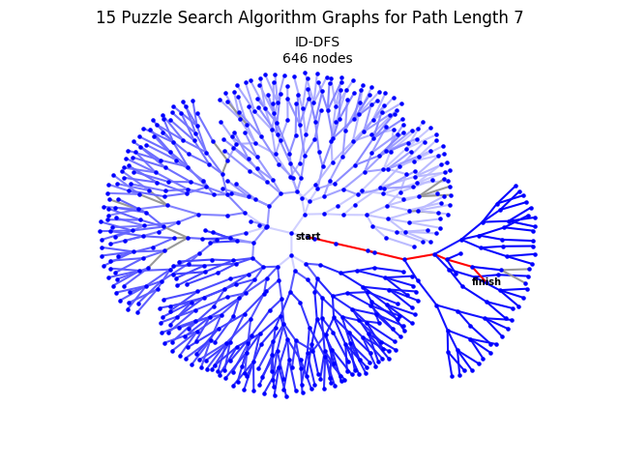This final part isn’t an optimization, but I decided to make network graphs for my different search algorithms just for fun because adapting my 15 puzzle methods to n queens wasn’t that difficult. It’s super cool to see how the different search algorithms determine the shape of the networks. The lighter colored edges were visited earlier.

For the original backtracking algorithm, it looks very similar to the basic dfs graph from 15 puzzle (right), because they follow a similar search pattern of go deep and revert. Fireworks!

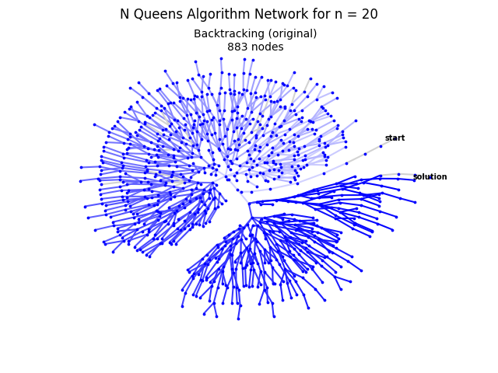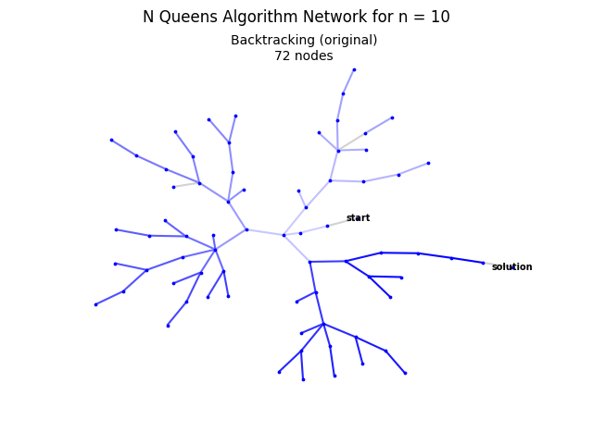

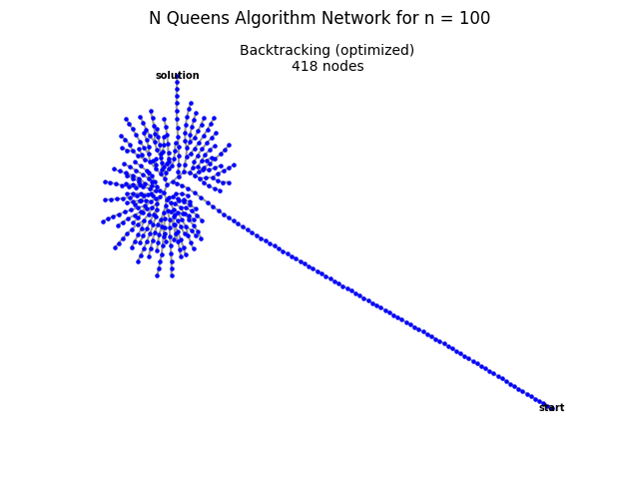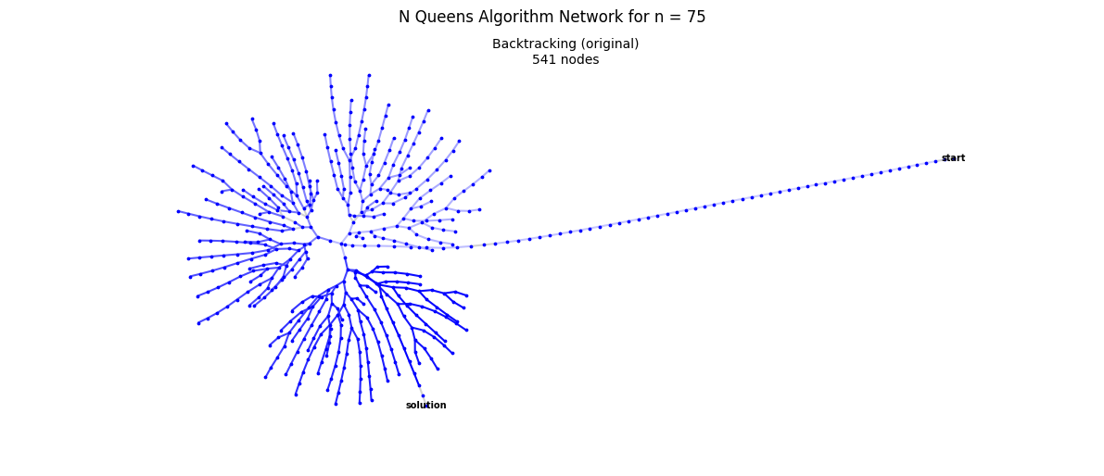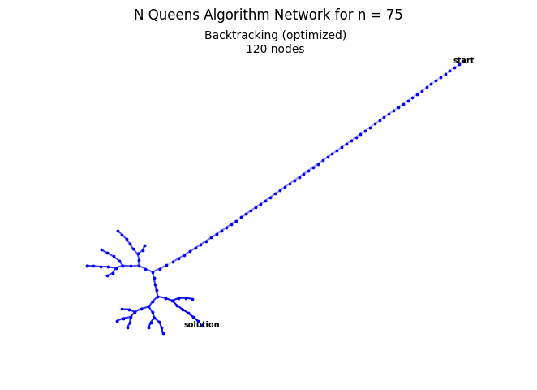 Next is the optimized backtracking, which has a palm tree type shape. This first one (right) is what most of them look like, and the next few networks I thought looked nice. The long neck has about n nodes in it (in this case about 75 nodes) and then in branches out for the last few nodes because the last queens start to have a lot of constraints acting on them, so they are more prone to having to backtrack. One reason the optimized backtracking algorithm is much faster is because it only goes into the inefficient explosion for the last year queens, not the whole thing.

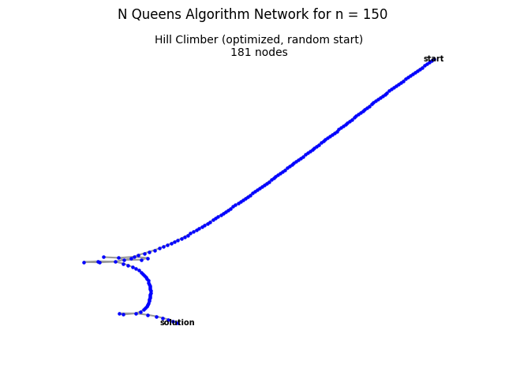 The hill climber network is kinda lame, because most of the time (left) it looks like

y = $\sqrt{x}$ drawn by a 3rd grader. Sometimes they get these zig zag things. These occur when it has to backtrack, but because of hill climber’s very informed heuristics, it recognizes that its going down a bad path quickly and reverts. The main differences between the basic and the optimized hill-climbers are the node counts and how many zig zags it has. For non-optimized (middle), it visits tons of nodes, and has to cut back a lot. This is because its randomly choosing the variables, so it takes more moves and isn’t as smart.

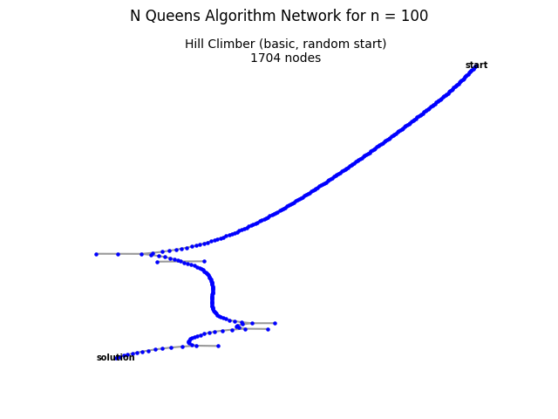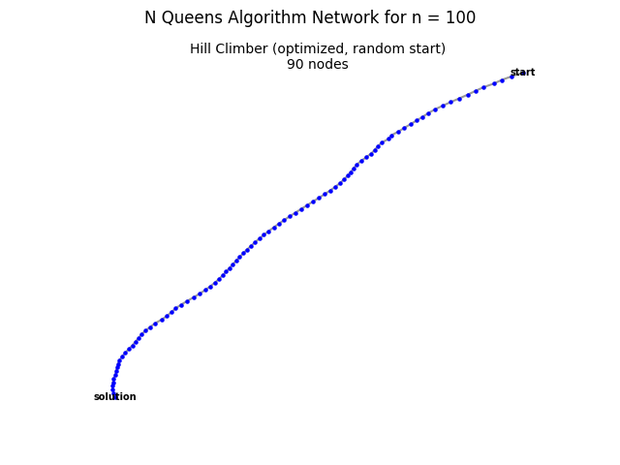

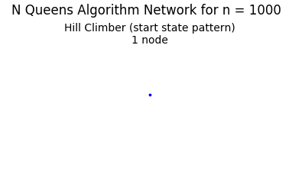And finally, the moment you’ve been waiting for- the network for when I solve it based on a pattern: